Preliminary Deliverable

History and nature of the company
Our company provides various subscription services for customers such as clothes, flower, groceries and any other products that customers want. As a global pandemic continues, people are seeking for online services which do not require any unnecessary contacts. Also, people do less shopping in order to protect from any diseases. Thus, their life satisfaction percentages become lower than usual. From this, we think that we could provide a better service to customers by using a subscription service.

IT products and services
As we mentioned before, we are using a mobile application which is a software, or an IT service, to provide a subscription service and customers can select the service they want.
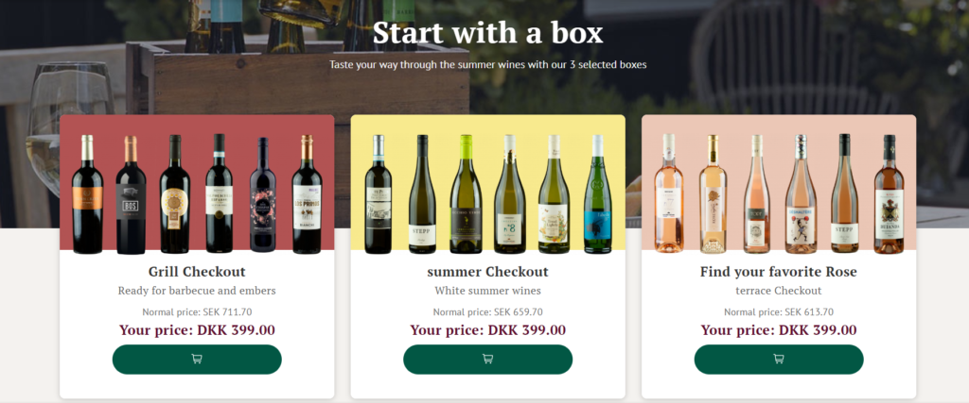
I brought an example of a subscription service from a wine company in Denmark and they provide physical products by using an IT service. Our company also designed similarly like Denmark wine company and we also do offer a rental system as well. We cannot offer a rental system for items like flowers or groceries, but we could rent things in a fashion industry. Plus, everything with subscription or rental system will be related with a delivery system as well and it means we also provide a physical delivery system.
This service will be our company’s main IT product, or a service and we will provide the best quality to customers.
References
[Subscription service example]. (n.d.). Retrieved from https://www.winefamly.com/

Subscription service image example

